Feature Scaling wo do at the last in feature engineering and it is easiest method in feature engineering.
Feature scaling isa technique to standardize the independent features present in the data in a fix range.

Now as you can see In above example that IQ is in range of 100 and CGPA is in range of 10 so when we do feature scaling then both columns comes under the similar range, for example -1 to 1. Feature scaring is extremely important in certain ML algorithm.

Why we need feature scaling?
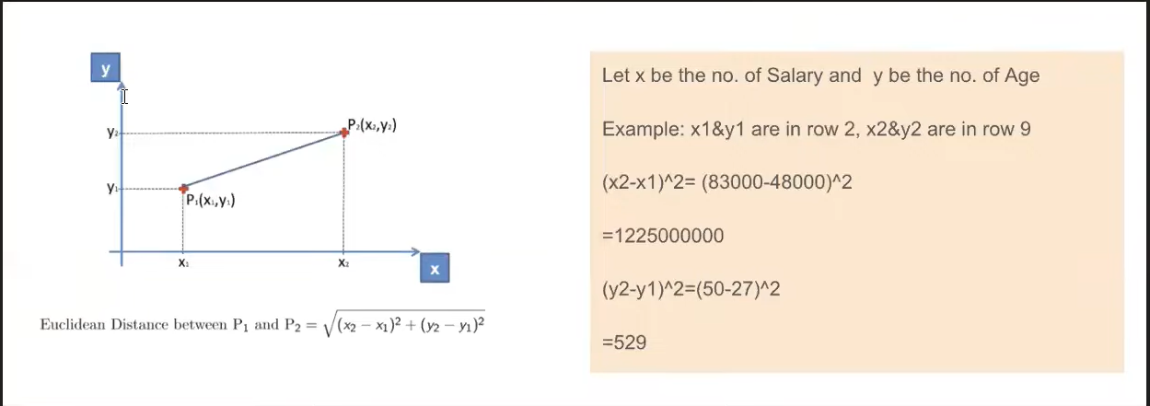
Suppose we have a dataset in which we have 2 columns

If we are using algorithm such as KNN what Ove algo will do is it will Calculate distance between 2 Points.

If you perform KNN on this value than your Salary column will dominant and it will not give expected result.50 that’s Why scaling so important.

Types of feature scaling.

- Basically there are 2 types of feature scaling.

Standardization:
It is also known as z-score normalization.
In standardization we use z-score so our data comes in range such as 0 to 1.
Lets understand this with am example suppose we have following data.

We apply following formula on our column.

What it will do is it converts all the data in to a similar range. Ant when we calculate mean of entire Column then it would be 0. Same happens with S.D. it will become 1. So entire data comes between range to 1.
Now we got a Question that how this entire things work internally?

Above graph illustrates that how Standardization actually works.

